Well only three weeks to go and panic is starting to set in. Not really anywhere near ready yet but very excited. Take off is 16th March.​
Saturday/Sunday
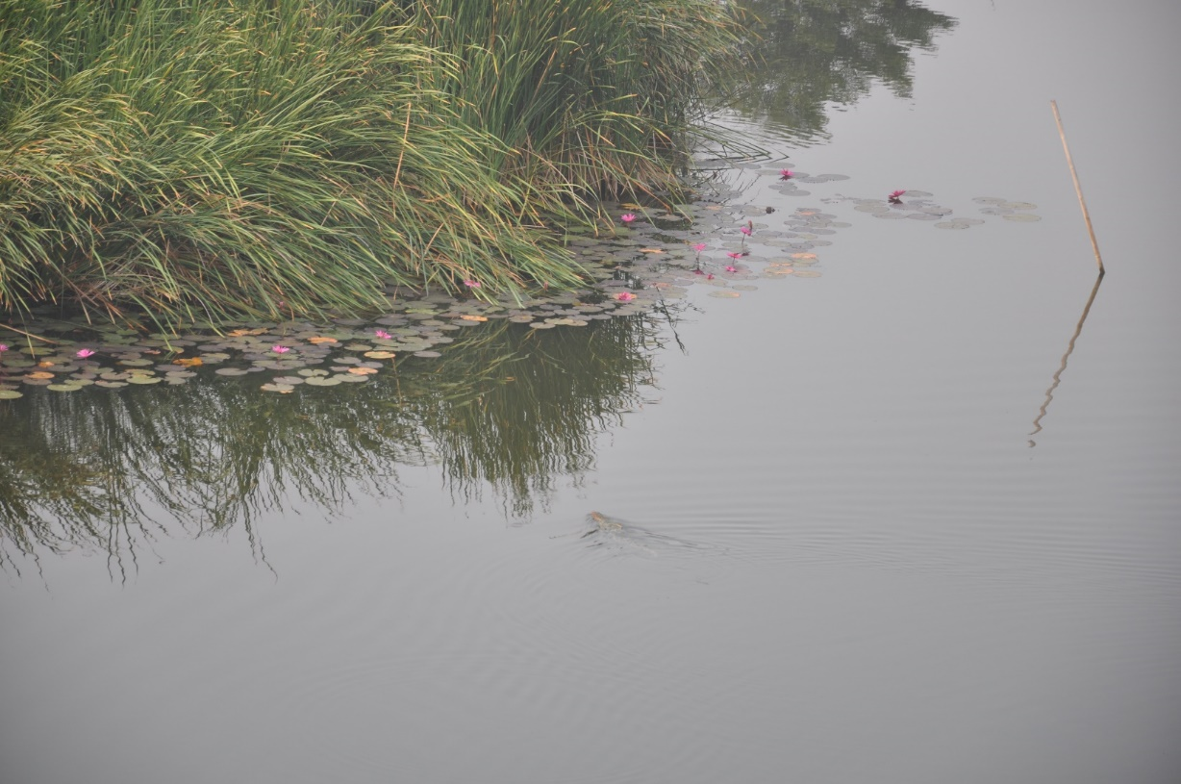
Finally got everything together & airborne. First leg of the flight to Bangkok was long but uneventful. Weather here was hot and steamy and unfortunately the hotel was not the best. The bed was a pretend mattress made of a wooden box the size of a mattress with a soft thin mattress about 50mm thick on top which compressed to nothing when you lay on it. Gail and I had little sleep and were both tired and sore in the morning. As an extra complication the hotel restaurant was closed due to some Thai law about what can be open on the eve of an election so Gail and I donned shoes and walked the rural town/village until we found somewhere to eat. The one exciting thing we did see was an anaconda swimming in the large drainage basin/lake beside the hotel. At least breakfast - fried egg, frankfurter sausages and mango was ok. Thank goodness we were at the airport early because the queues and processing took ages. Every departing passenger was funnelled through one point where our boarding passes were checked. Once again a run for the plane as the last call signal was flashing. After our dash for the plane we were disappointed that we still had passengers boarding up to 5 minutes after supposed take off time. A happy ending though as we landed in Nagoya and were greeted by Gaye. She gave us an orientation of the airport and train station before heading for the hotel. Gaye left us at our hotel with an agreement to meet at 11am next morning and after sorting the bags we crashed in to bed.
Anaconda swimming in the lake outside our hotel

Monday
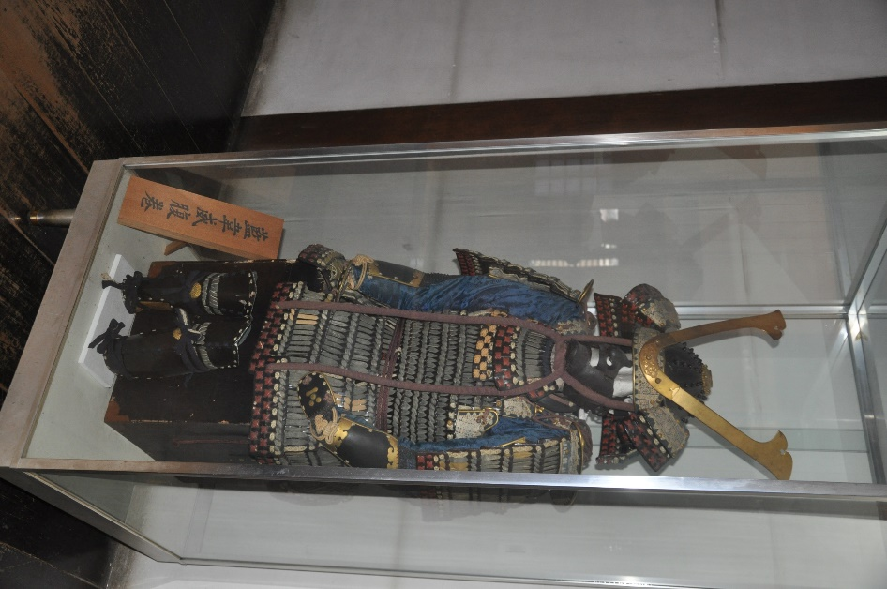
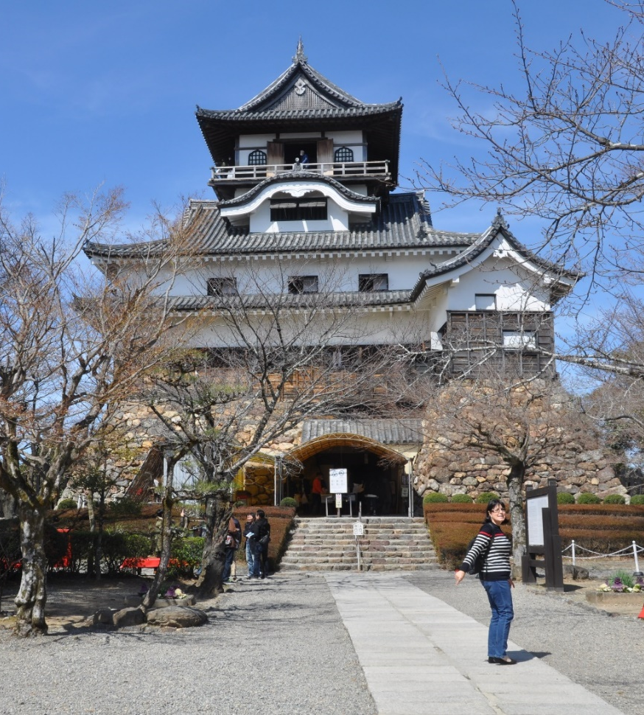
Gail and I up bright and early (9am) when we went for breakfast at a cafe before meeting Gaye. She then drove us out to Inuyama Castle, one of the four castles designated as national trasures in Japan. We lunched at street stall in the historic area around the castle before heading to Nagoya Castle. We didn't go into Nagoya Castle but viewed it over coffee and desert and a long chat from the Nagoya Castle Hotel opposite. We then went back to our hotel before going out again at 10pm to an Osen bathhouse. This was quite the experience. Finally back to the hotel again and in to bed about 2am.
Inuyama Castle
​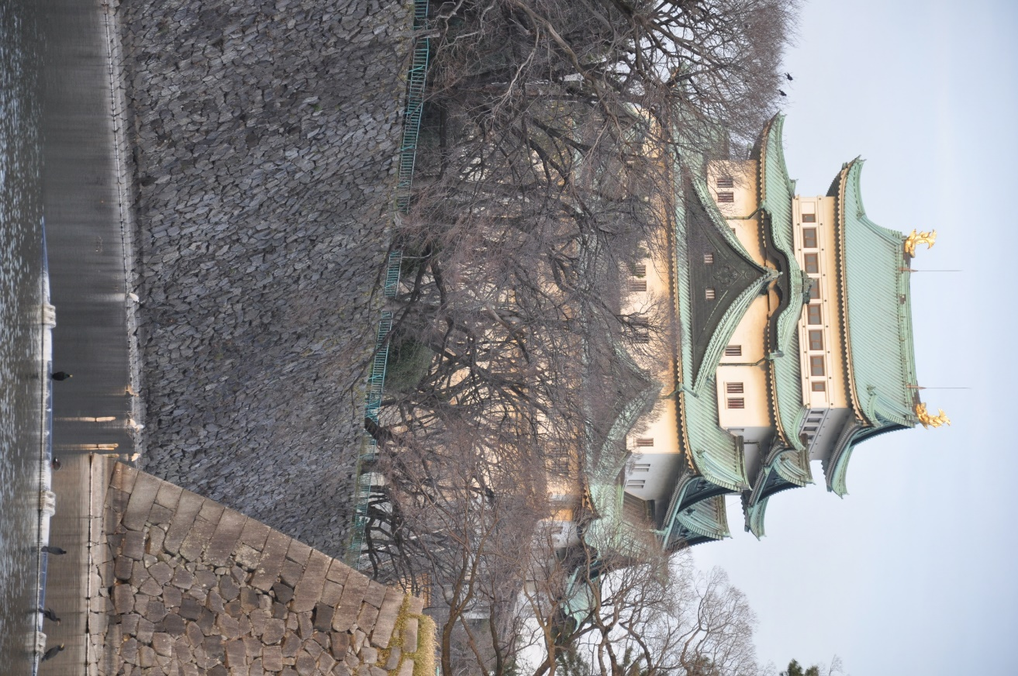
Nagoya Castle

Tuesday
Up late next day and out to the Toyota Car Museum. A quite fantastic spread of cars although not quite Gail’s cup of tea. We then went back to Gaye’s house before going out to an evening meal with two of Gaye’s friends and the parents of one of them. An interesting evening followed. The parents only spoke French, the girls spoke French, Japanese and English. Gaye spoke Japanese and English and we spoke only English. The food was Japanese so lots of fishy stuff and odd vegetables – mostly raw but some battered as well.

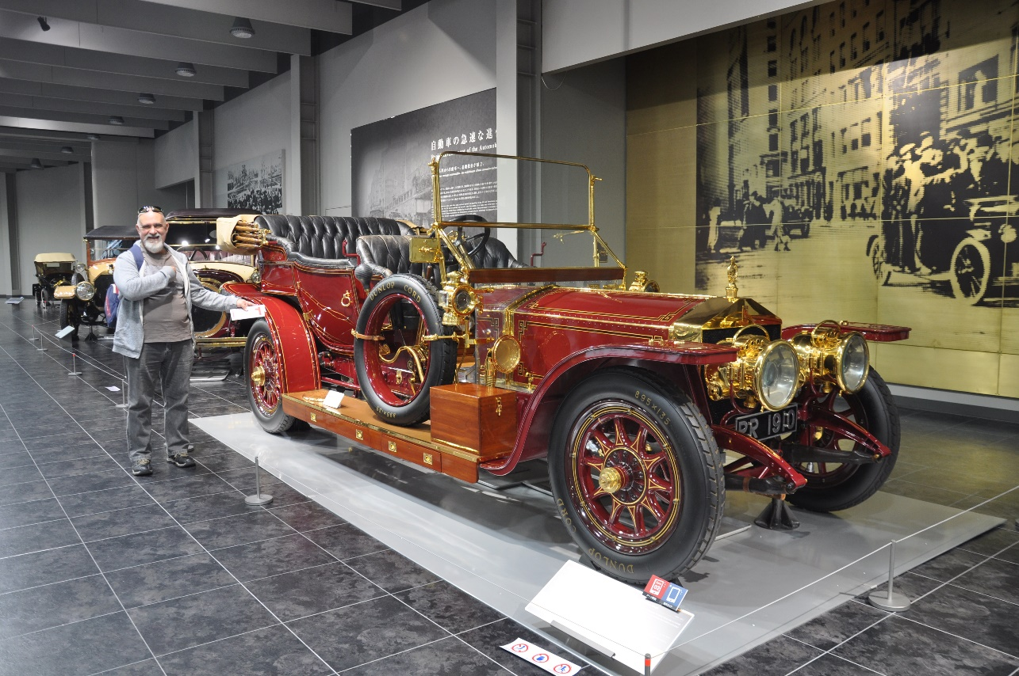

Wednesday
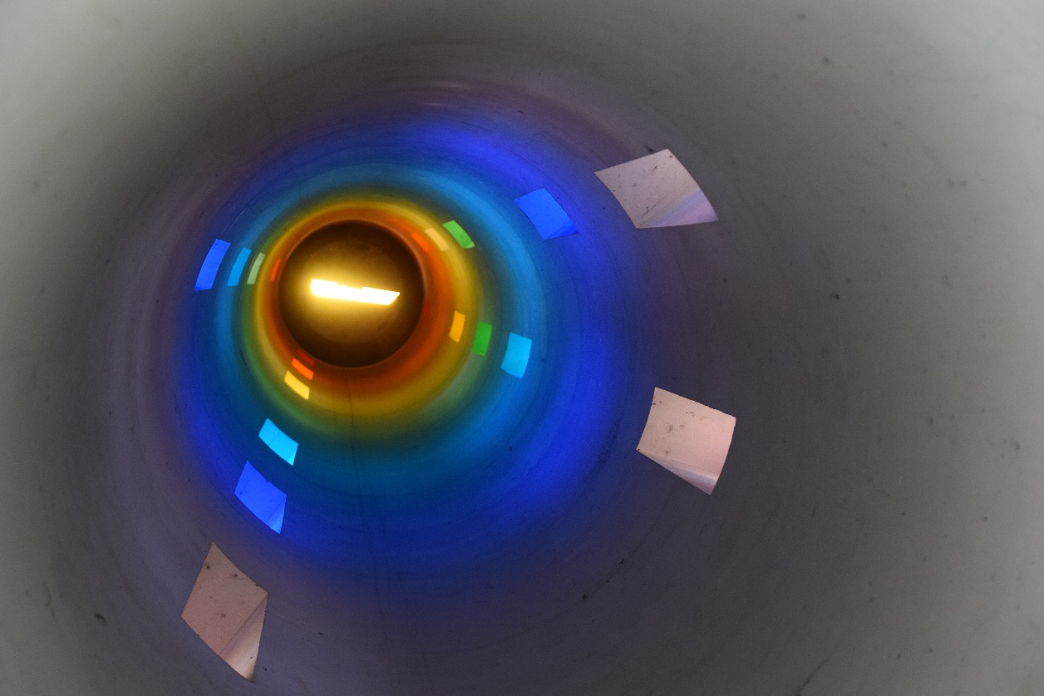
Stated with a picnic breakfast with Gaye at the large park around a cemetery. Checked out a temple within the park and a tower which is topped with a prism the shows the colours of the rainbow down the insides of the tower. Apparently at the Equinox and when the sun is directly overhead the colours reach to the floor of the tower. Sadly we were a day too early to see it reach the floor.

Thursday
A travelling day today. Gaye helped us get our train pass organised and guided us to where we needed to board the train for the first leg to Hiroshima. We managed the transfer at Shin Kobe no worries and safely arrived in Hiroshima and the Via Inn Hotel (great location thanks Gaye). On Gaye’s advise we booked the return tickets to Kyoto and just as well as they were filling up fast. Tea was a local speciality called Okonomiyaki which was tasty, filling and healthy. It’s a plain flour thin pancake then layered with grilled cabbage, bacon, bean paste, an egg then topped with sauce and a topping of choice if you want.

Friday
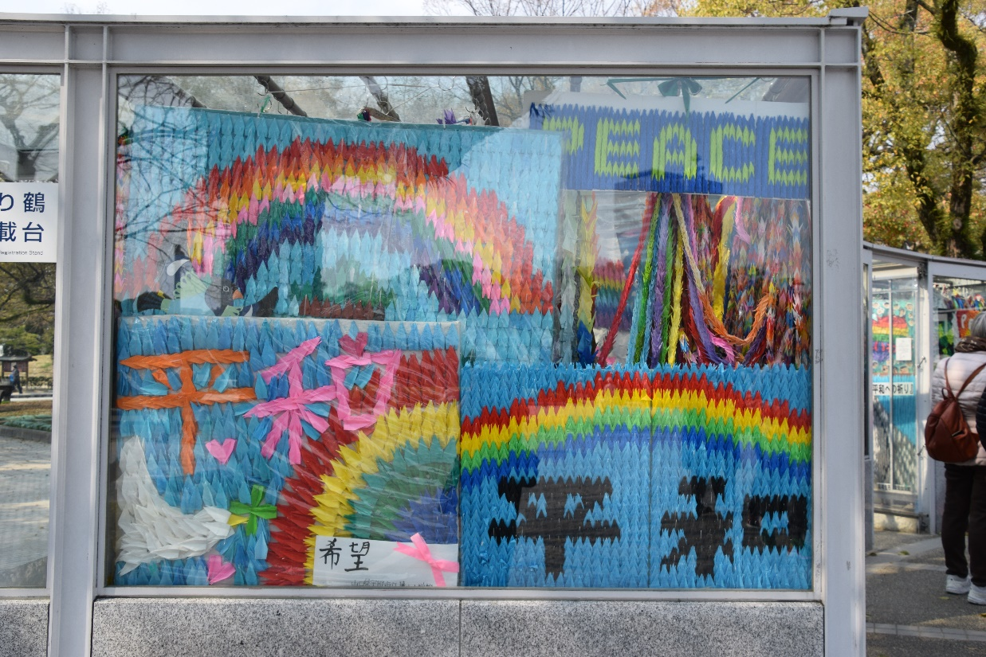
Caught the bus to the Hiroshima Peace Park Museum. This is a museum showing the events leading up to, during and after the atomic bomb was dropped on Hiroshima and then Nagasaki. It is very moving but also informative. We spent quite a bit of time there and the surrounding park which contains many memorials to different aspects of the bombing. The paper cranes that school children from around the world make as part of the history of the effects of the bombing end up in a display and memorial in this park. After all our walking we walked back to the hotel from the park and collapsed in our room before going out for tea.
Display made of thousands of paper cranes

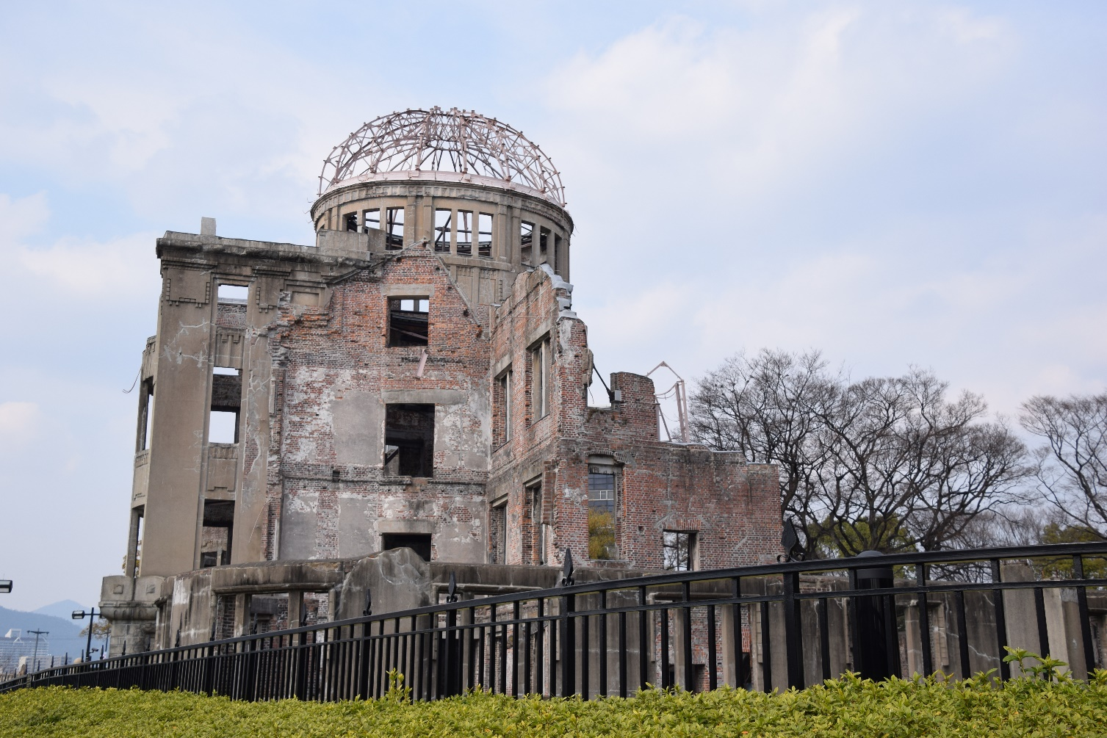
Dome – one of the very few surviving buildings and almost right at the epicentre of the explosion

Saturday
A day trip from Hiroshima to Miyajima to see the floating torii gate and shrine. A lot of walking involved and we were certainly staggering by the end of the day. Well worth the effort though and the tides were right for us to see the gate sitting in the water and at the end of the day to see it exposed. We took the ropeway (cable car) to the top of the mountain for a panoramic look around the bay. The island was very crowded but still able to get to places for photos. The Japanese are sooo polite.

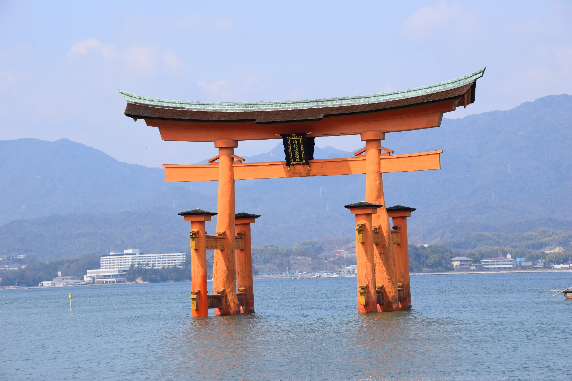

Sunday
Another travelling day today up to Kyoto. All went well until the subway transfer where I missed our stop and we had to get off and cross the platform and go back one stop. We (I) then turned right coming out of the station instead of left which turned a 5 minute walk to the hotel into a 20 minute walk. Still we made it and have now unpacked and are settled for 6 straight days so can relax. There is a Chinese restaurant attached to the hotel and we ate there for our evening meal. The tech gear we brought with us means we can watch movies I have on a hard drive on the TV so we chilled with that before bed. The hotels are all very similar just slightly different in size and layout. This been our biggest so far as I can sit at a (small) desk and type rather than balance the laptop on the bed or a case.

Monday
Caught a local bus out to the Kitano Tenmangu Shrine Markets. They sell all sorts of things here including cheap knock off kimonos from China. There were lots off old toys and bric-a-brac like our markets. Had a great day here and could have spent heaps on interesting stuff but held back by lack of packing space. Did manage to pick up a bum bag however after much fun with the elderly couple who had the stall. We also picked up a few things for the grandkids. We ate from a couple of the food stalls and also went through the shrine gardens. An enjoyable day.

Tuesday
A change from the itinerary today and we went to Himeji Castle. Getting used to catching trains and buses now. This is a large complex and we spent quite a bit of time here. The castle is perched on a high point and is then a number of floors high itself so we did LOTS of walking and climbing of stairs. By the time we finished at the castle and got back to Kyoto we were very tired.

Wednesday
Visited two temples today, Kinkakuji and Ginkakuji. Kinkakuji setting is on a small lake and very pretty. It is covered in a gold colour and looks very impressive. Although the gardens are nice and relaxing you are not allowed to to sit and eat in them so no chance to just relax and enjoy the surrounds. Ginkakuji had nicer gardens as it was on the side of a hill (more climbing) but still no eating. While the gardens were nice here the temple was a bit underwhelming and we walked passed it without realizing what it was at first. Still only the odd cherry tree in blossom and so back to the hotel. Another day of walking done.

Thursday
Met Gaye while we had our breakfast at Starbucks this morning before heading off in a taxi to meet her friend Hitomi to take part in a tea ceremony. The ceremony was conducted at Daitokuji temple. They hold a tea ceremony here once a month in honour of an ancient tea master who is buried in the gardens here. It was a short ceremony so Hitomi talked us in to going to a museum and ancient shrine with a large wooden Buddha that was once covered in gold. It was a picturesque garden but the shrine and museum a bit flat. On top of that the taxi fare was around the $120 mark.

Friday
Time for laundry today so we walked to a laundromat and did the laundry and relaxed for an hour. After getting back to the hotel we bussed out to the Gion district which still has some old streets of buildings left. So we walked around the area for the afternoon and then headed back to the hotel.

Saturday
Check out today. We left the bags at the hotel and took a flying visit out to the Philosopher’s Path at the Ginkakuji Temple in the hope that cherry bloosoms would be out. Sadly while seemed a few more still not he masses we were hoping for so after a few photos and a bit of a walk along the path we headed back to pick up our luggage and catch the train to Takayama. Unfortunately with the Kyoto traffic and a bit of rain we managed to miss the train and had to reschedule our ticket for 2 hours later. Got in to Takayama finally at 8.30PM.

Sunday
Out for a walk today to the folk village museum. Weather is cold, raining and bits of snow with intermittent sunshine. Anyway we walked. Supposed to be a 30 minute walk but we managed to turn it in to a one and a half hour walk – mostly up hill. We did enjoy the village though and spent quite a bit of time there (and caught a bus back). Needed to relax when we got back so watched a movie and went out (in the cold) for tea at about 7.30pm. unfortunately most places were closed but did manage to find a little place just before it closed and enjoyed some of the best fried chicken I have ever had. We are undecided what to do as the weather is still a mix of rain, snow and sunshine but always cold. Checking to see if maybe we cut our losses and miss Matsumoto Castle as it is a 3 hour bus ride over the mountain.

Monday
Walked the old part of Takayama today. A lot like the old parts of Kyoto. Nice old buildings which have been turned into small eating places of various sorts or souvenir shops so a bit same - same. Weather similar to yesterday a bit of rain a bit of snow.

Tuesday
Weather here in Takayama is going to be horrible so we decided to go over to Matsumoto today. Caught the bus across the mountains. Not a 3 hour trip as I thought but more like 2 hours. It was an exciting ride with steep edges snow on the road and a very skinny road with lots of bends. Enjoyed Matsumoto and the castle. Lots of climbing, walking and photos. The ride back was half in the dark and the snow was heavier with lots of traffic on the road making the crossing over the mountain. Got back to see that it had snowed in Takayama and there was a lot of snow about. Very cold as well so we were glad we had gone across to Matsumoto.

Wednesday
Got up early and caught a bus back to Nagoyo to see if we could catch more cherry blossom out before we went on to Tokyo. Gaye met us and guided around a couple of spots before we had High Tea at the Marriot and caught our train to Tokyo. Arrived in the dark after catching the local line out to the hotel and had to drag the bags through crowded streets on narrow footpaths. I don’t think we were very popular but the Japanese are to polite to make a fuss. The hotel is very nice and the biggest room we have stayed in so far. Which is not saying much for a Japanese hotel room.

Thursday
Today was Mt Fuji day. As it was a clear day today we decided we would make an effort to get some views of Mt Fuji. We caught a train back to Shin-Fuji station and walked towards the mountain. Got some good shots, we think anyway after a lot of walking, AGAIN. As it looked like the weather would stay clear enough we decided to try a view from another location. Mistake. We caught a train back to Hakone which is supposed to have a highly rated view. Turned out it was expensive and not so highly rated. May be okay at just the right time but you would need to stay there to hit it just right. Left disappointed after using a lot of time to get there and back. Had fish and chips for tea at a supposed Irish pub. Food was good anyway and certainly a change. Tired after a long day.

Friday

